**Multiclass Classification**

We will now be moving on to dealing with **multiclass classification**, where the output may have one of multiple values, e.g. , , , etc. Again, regardless of the true meaning of the classes (such as weather types), we will be using numbers for simplicity.

In multiclass classification, we have multiple types of data points, as shown in the diagram below:



To deal with this, we use the **one-vs-all** technique. Basically, we take each class in turn and treat the problem as a **binary classification** problem for that one class.

  

Now, what does this mean practically? For each possible classification, we will get some hypothesis, . This tells us the probability that class is the correct class. For the example above, there are three possible classes, so we will get three values. Suppose , and . Based on this, we decide that class is the correct class, since gives us the highest probability.

## Ambiguous Values

Consider that for three classes, the values we get are , and respectively. According to our previous process, the answer in this case should be class 1, since that has the highest probability. However, in this case, we have a bit of a problem.

Consider the decision boundary for a simple binary classification problem



If , we can easily say that the output should be . However, if the output should be .

Following this logic, for the three values , and , it would be more accurate to say that none of the classes are right. We have an **ambiguous** situation. The diagram below should make this clearer:



Here, we have four classes instead of three, but the problem remains the same. For any points in the area in the centre, the best answer would be that none of the classes are right. But we still have to give an answer, so which one do we pick?

To deal with these, we can use a **linear machine**. Linear machines create diagrams such as the one below, which have no ambiguous regions.

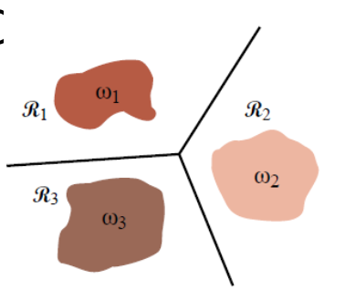

We can still have points that fall exactly on the boundary, but we can prefer one class over the other in those cases.